**COIT20259: Enterprise Computing Architecture**

**Assignment 2**

**Title: Movies and Games**

**Individual Teamwork Report**

Due date:   
Friday, 29 May 2020, 11:55 PM

Campus lecturer: Muhammad Baloch

Tutor: Prabhu Singh

Unit Coordinator: Wei Li

**Team Details:**

Student name: Aman Kumar Maharjan

Student number: 12102452

Team Leader: Aman Kumar Maharjan (12102452)

**Team Members:**

Tammy Kanashiro(12100880)

Damodar Chaulagain(12099970)

Contents

Team formation: 3

Technical problems: 3

Collaborative Problems 4

Teamwork success: 5

Communication Skills: 6

# Team formation:

We were classmates from the term1 and had built strong rapport from beginning. So, this project was best opportunity to work together. We had a common dream of making things happen. So, we worked together to form the team to complete this project.

**Role:**

In the assignment, I worked on the business tier of the project. I was assigned to work on the controller and EJB beans for accepting request form presentation tier and pass it to the persistence layer. Recording the records for customer, order, movies, games into database from user interface as well as retrieving results back to the user interface from the database are performed by me. Next, testing was also performed after the program integration. In the documentation section I worked on the workflow of the whole program.

**Project timeline:**

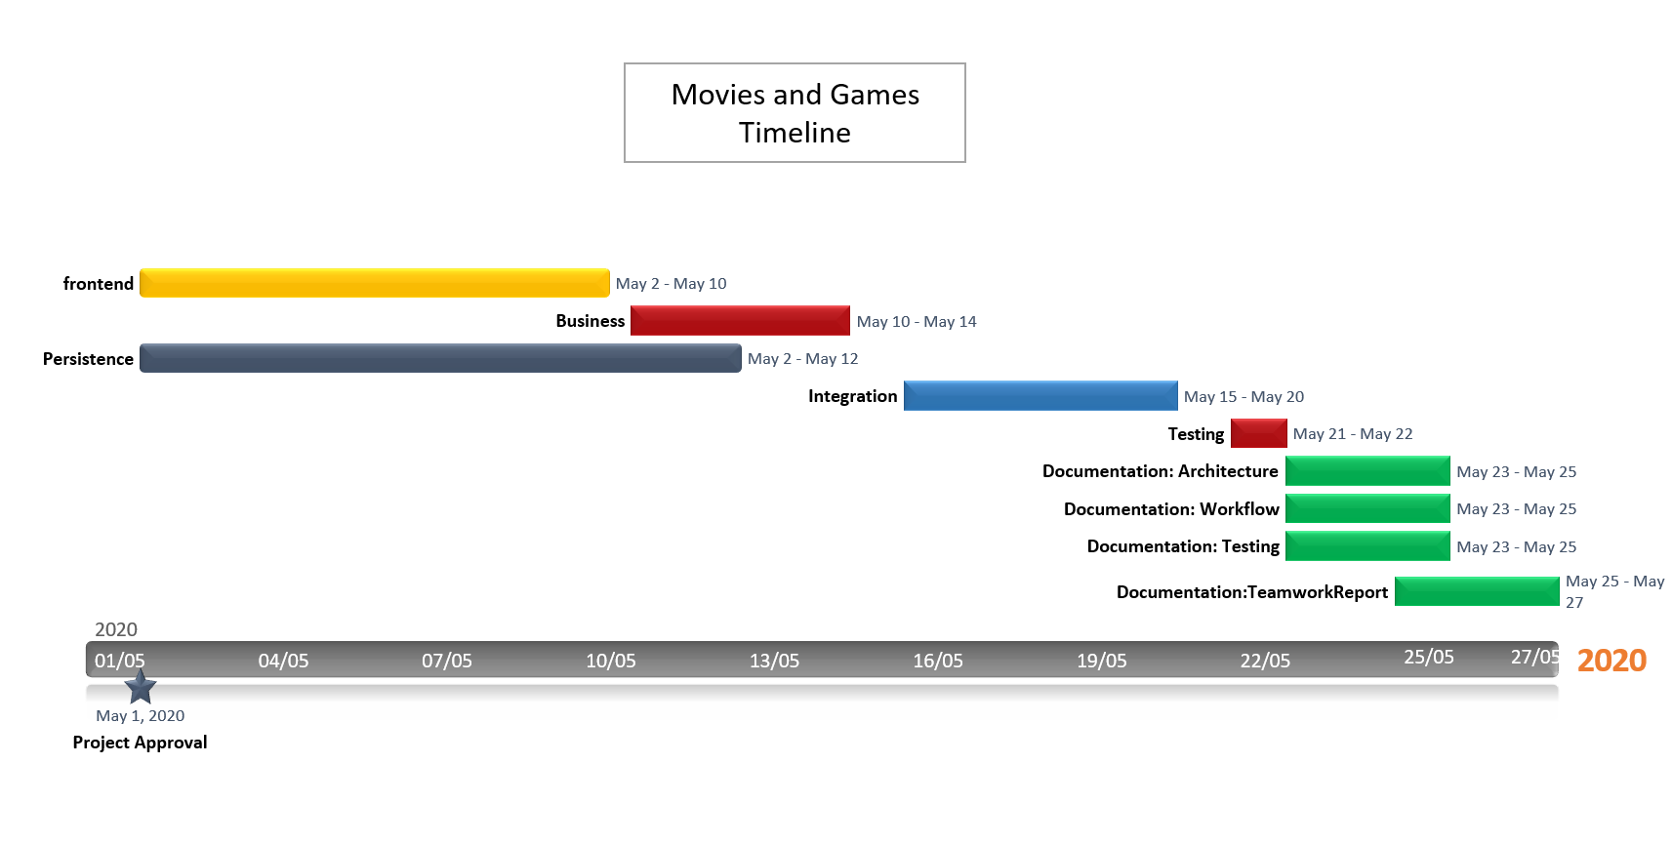  
Fig: Movies and Games project time line

The project was started on the 1st May 2020 and completed on the 27th May, 2020. Business tier was started on the May 10 and completed on the 14th May. Document workflow was created on 23rd May and completed on the 25th May.

# Technical problems:

The technical problems that are faced on doing the project are as follow:   
**Integration with other layers:**

Since, I worked on the business layer, it was technically challenged to understand the code from the persistence layer and the presentation layer, and finally integrate them. I constantly communicated with my team member and studied the requirement specifications in the assignment specification to figure out the flow of the program. Finally, I integrated the whole project.

**Time limitations:**

Another challenge we face around is the time limitation. Since the whole project must be completed within the deadline, we have to distribute our tasks in such a way that one module should not affect others. So, we created the project timeline assigned our task based on the tier to complete the task as per the schedule.

# Collaborative Problems

**Tracking the individual task:**

It was very hard to track the individual tasks in the beginning, so we used online project management tool Trello for monitoring and tracking the tasks of the individual. It helped us to find break down the task into smaller pieces and track the status of the task whom it is assigned.

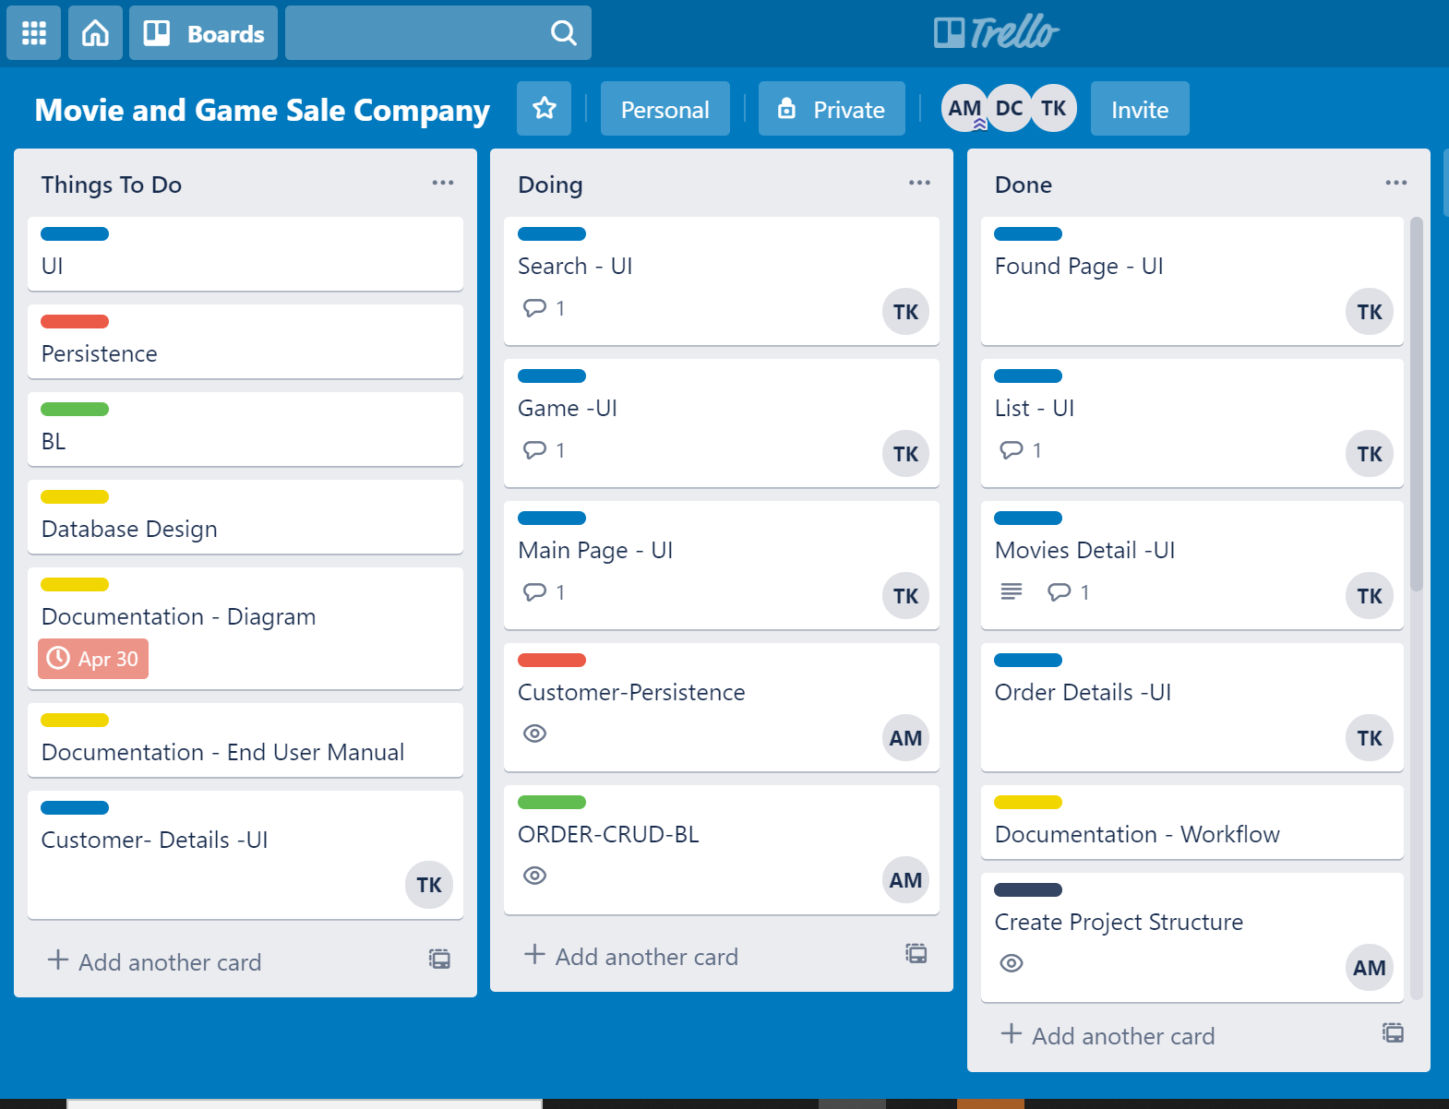

Fig: Trello usage

**Communication:**

Since, we all were working remotely from our location, we encountered the communication problem in our project. For transparent and clear communication purpose, we use cqu mail as well as WhatsApp group. Creating group in WhatsApp offered us to ask queries and messages. In that way we were successful in constant communication

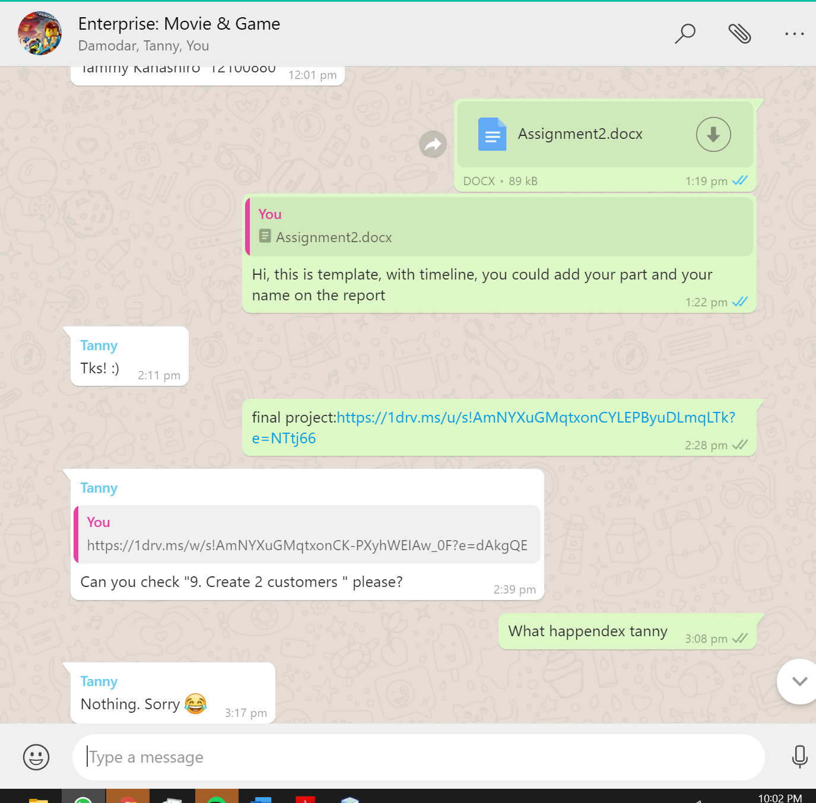

**Fig: WhatsApp group formation**

# Teamwork success:

Success of the teamwork is defined by the following factors:

* **Strong Leadership:** For success of a project, leadership is always above the teamwork. Strong leadership provides the direction to the team. Being a leader, I guided my team so that our whole project could be successfully completed within the due time.
* **Planning**: Planning allows for the achieving the goal by allowing for effective decisions, allocating resources and maximizing the productivity. I planned the timeline of the project and assigned tasks to each team members. It helped us on focusing on our objective without losing our way.
* **Trust**: Mutual trust between team member is important for the proper co-ordination and effective communication. It allows for proper collaboration and management.
* **Effective Work distribution:** Proper work distribution is necessary for smooth team work. Based on the nature of the individual, the task must be assigned. This helps for the maximizing time and money leverage.

# Communication Skills:

In the project, I felt very blessed to develop following communication skills:

* **Clarity**: While passing the information, we should always deliver the clear and concise information to the team. There should be transparency in the flow of information. It avoids miscommunication.
* **Friendliness**: Not only clear information is necessary, friendly behaviour and kind words are also necessary to provide instructions. It allows us to earn the respect and add value on our character.
* **Feedback**: Rather than direct commenting on the work, we could provide the positive feedback for correction on the work. It maintains the positive atmosphere in the team members.
* **Listening**: One should be able to listen the words of others because we could learn many ideas from them. It develops our open mindset.